OYC Waikouaiti Race Sunday 10 March 2024 0930hrs
Race Instructions: Start, Taiaroa Heads – Waikouaiti – Carey’s Bay
Race Entry: ONLINE ENTRIES ONLY. Entries close 2100 hrs on Saturday 9 March.
After entry, entrants can update or withdraw by texting or calling the Race Officer, Pete Wilhelmsen 021 169 2359. A minimum of 3 yachts are required for the event to go ahead.
Safety & Disclaimer of Liability: Competitors participate in the event entirely at their own risk. The OYC will not accept any liability for material damage or personal injury or death sustained in conjunction with or prior to, during, or after the event. All competitors must wear life jackets at all times while racing. Each yacht must carry and monitor a working VHF radio switched on to Ch 62. This is not only for safety reasons but also for receiving details of any course changes from the Race Officer. Any boat withdrawing from the event must notify the Race Officer at the earliest opportunity.
Start: The start line is the transit line from the white staff on the Mole at Taiaroa Heads and Green Pile #1a. Start flags will be flown on the mole with a five minute start sequence. First warning signal 0925hrs.
Turning mark: There is no turning buoy, instead once inside the transit line between Karitane Point and Cornish Head, a yacht can turn for home once they have a line of sight on the Karitane fishermans jetty shed at the mouth of the Waikouaiti River, see picture below.
Finish: All yachts should record their time at two points. 1. As they return through the start transit line at Pile 1a in the event the race needs to be shortened, and again at the Finish line at Carey’s Bay, being the transit line between Red Pile 24a and the white staff adjacent the scrubbing grid on Aramoana Rd. Finishing times need to be sent to Pete by phone or text as soon as practicable afterwards.
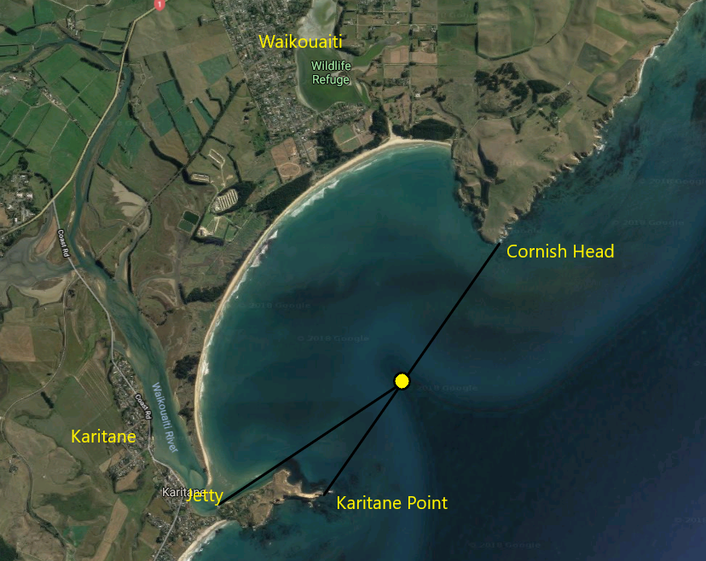
Tide: HWPC 4:07; 2.3m

